Creating an Event
- Under date – need an option as TBA
- Need Bigger Display for Event
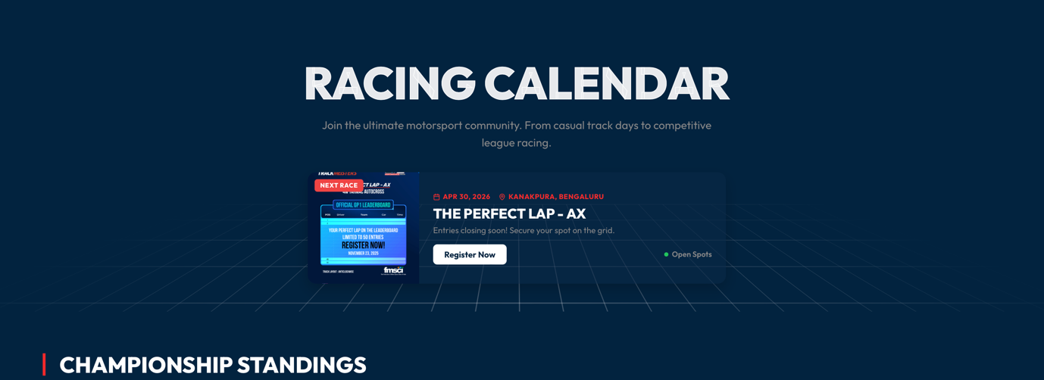

- Remove Championship Standings and how championship works

- Event types :

Racing Events
Time attack and autocross competitions across diverse terrains. Push your limits and earn your place on the leaderboard.
Trackdays and Training
Performance focused track sessions and driver coaching designed to sharpen skills and unlock faster lap times.
Customised Corporate Events
Premium motorsport experiences for automotive brands including track activations, product demonstrations, and high impact customer engagement.

- Need sizes of thumbnails and BG’s so that I can create correct size artworks

- Hero pages action button and images needs to be bigger

Registration form

- Add heading and Descriptions for different types of classes Ex: INAC 1 will have 5 classes, INAC 2 will have 8 class, INAC 3 will have 6 classes, etc

- Need indemnity ( format will be given )

- Need an option to upload screen shot of payment and this is about be mandatory * to submit registration

- Remove comments and special requests

- Export CSV does not work and Event specific CSV should be available

HOME PAGE

- Upcoming events does not work
- F1 Fantasy does not work
- Admin access is needed for home page

Leaderboard
- Team/Tuner name to be added
- Can Lap Video link be added here

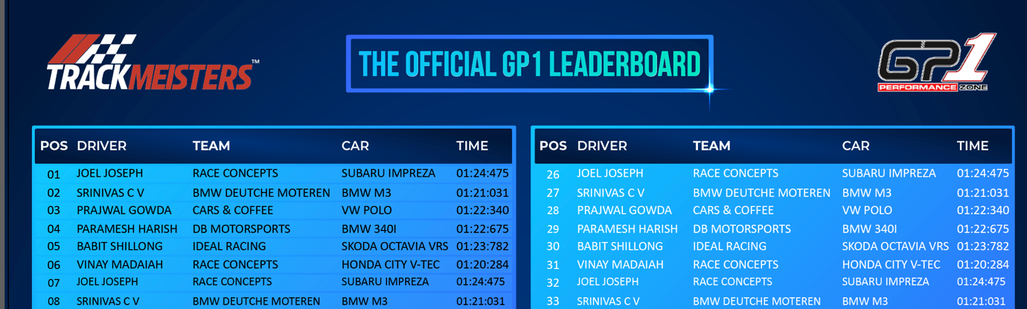

Tickets
- Tickets Registration has same details as competitor
- Must have option to select multiple tickets

Media
- Filter by event option needs to be added
- Album sort of style is better

Classifieds – Performance Cars and Race builds

- Transmission – Manual entry better than drop down

About
- Remove Engineered passion – will provide a different tag line
- Need to add a picture in the BG
- Remove Events hosted, active drivers, etc at the moment, etc
- Under reliability
Remove 24/7 in both places
Remove Offical Affiliations
Remove in the Spotlight
Remove FIA Grade Tracks and add this
--Motorsport Standard Operations
Events conducted using professional timing systems, scrutineering checks, and organized race procedures.

